Name: Ali Albayrak

Student ID: P304320

Portfolio 3.6 Exceptions and Assertions

Vocabulary

try-with-resources: A certain kind of try statement that contains resources.

class invariant: An invariant used to evaluate the assumptions of the class instances.

conditional statements: Certain types of boolean statements that allow you to test specific aspects of your code.

try and catch block: Key statement for handling exceptions in Java.

Internal Invariants: An invariant that handles boolean statements to test internal values.

decision-making statements: An invariant that handles conditions in control flow statements.

Multi-Catch Statement: A statement that allows you to handle multiple exceptions.

Finally: An optional addition to a try-catch statement that will always be executed.

Exceptions: Run-time errors that can be handled inside the program.

1.You would like to write a program that will open a file called “myFile.txt”. Write a try catch statement to open the file and catch the error if the file fails to open.

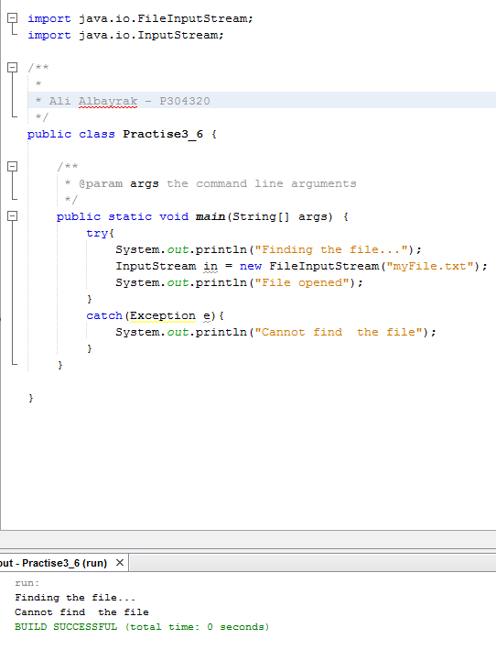

2. Create an exception called “myException” that prints out an error message when thrown.

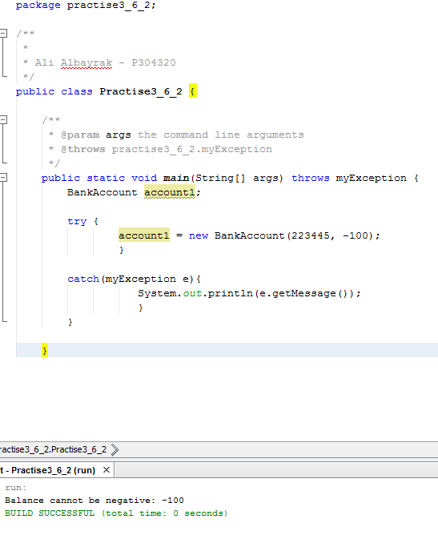

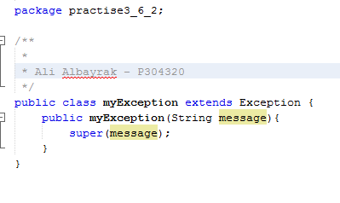

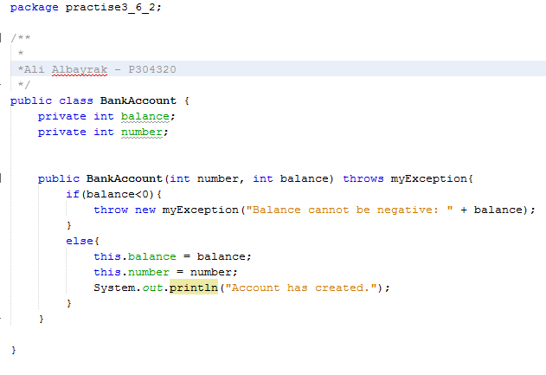

3. Create a block of code that utilizes all three types of invariants and asserts their values.

